***My Lion to Color***

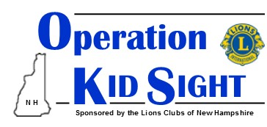

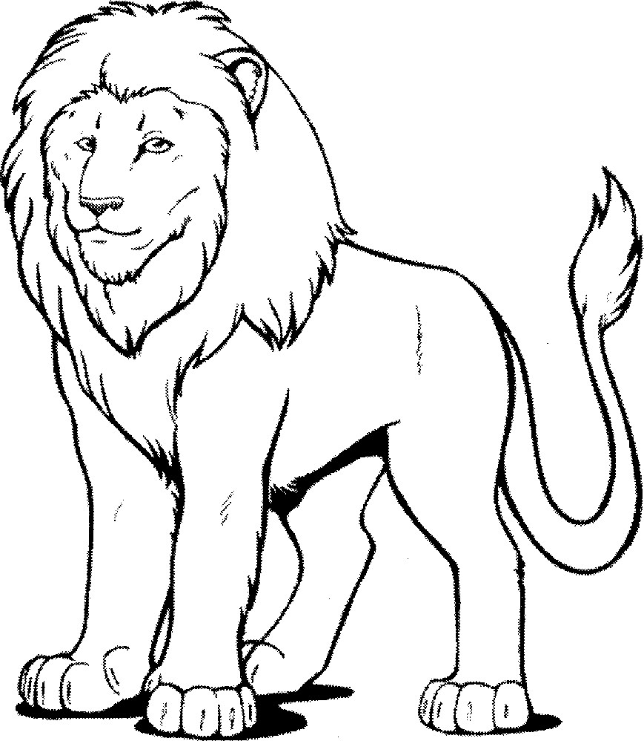

***My eyes were tested today by the***

***______________________ Lions Club!***